**Step 1 :** **Create a Github Account ,visit** [**https://github.com/**](https://github.com/)



**Step 2 :** **Create a a new repository**

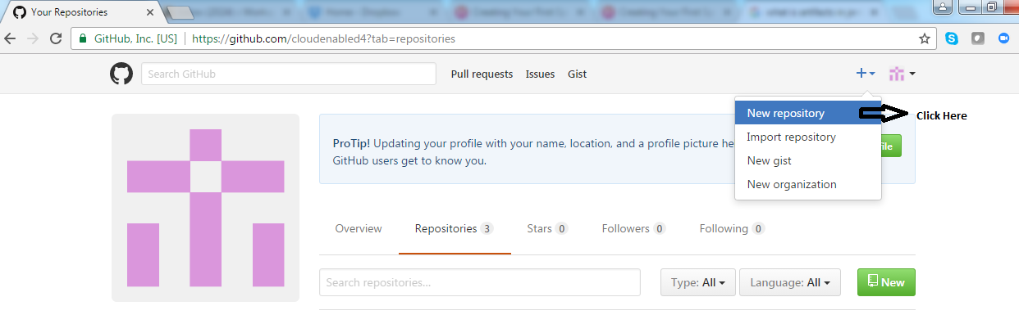

**Step 3 :** **Name the repository as “public-repo”**

